**Neeraj Mourya**
has
**0**
workspaces. Stats below are a sum of assets found across all workspaces.

**Stats**

* They have **4** campaigns
* They have **4** active campaigns
* They have **9** triggered campaigns
* They have **4** Active triggered campaigns
* They have **4** re-occurring batch campaigns
* They have **4** batch campaigns
* **3** landing pages
* **2** forms
* **2** emails
* **0**
  Snippets
* **1** uploaded files
* 7**23**
  Leads
* **2**6**93** programs

**Snippets**

**Neeraj Mourya**
is **not** taking advantage of snippets. Snippets are reusable blocks of rich text and graphics that the client can use in their emails and landing pages, and it is a great timesaver!

https://experienceleague.adobe.com/docs/marketo/using/product-docs/personalization/segmentation-and-snippets/snippets/create-a-snippet.html?lang=en

**Programs**

**Neeraj Mourya**, has created a lot of campaigns and content in Marketo. There are two types of smart campaigns: Batch and Trigger. A batch campaign launches at a specific time and affects a specific set of leads all at once. A triggered smart campaign affects one lead at a time, based on a triggered event. To learn more about Smart campaigns in Marketo. visit :https://docs.marketo.com/display/public/DOCS/Smart+Campaigns

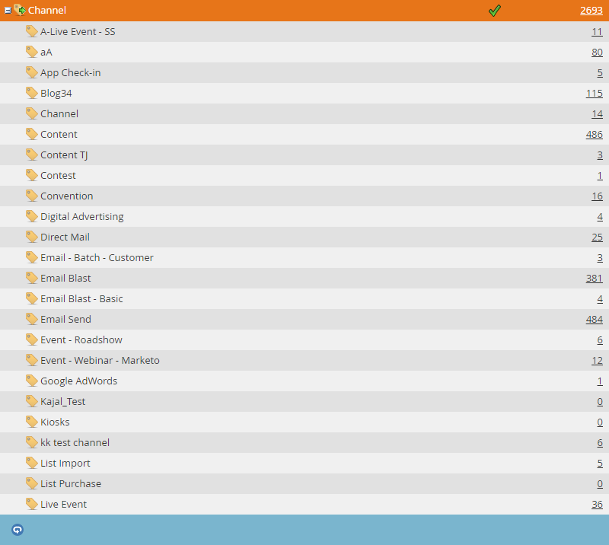

**Models**

**Neeraj Mourya**,
Has previously built
**2**
models in Marketo. Revenue cycle models take marketing to the next level. They model all the stages of your entire revenue funnel—from when you first interact with a lead all the way until the lead is a won customer.  
**Neeraj Mourya**
has created the following Revenue Cycle Models in their Marketo instance:

**Lead Scoring**

* **Neeraj Mourya**
  has
  **1**
  lead scoring campaigns built out taking into account behavior,successes and decay.
* **Neeraj Mourya**,
  is executing multiple score changes with single campaigns.
* **Neeraj Mourya**
  is using MyTokens in their lead scoring campaigns which allows for a Marketer to quickly, and easily, control from a high level their lead change scores
* **Neeraj Mourya**
  has built
  **1**
  campaigns reducing lead scores when leads exhibit undesirable behavior

Marketo’s lead scoring capabilities are far more robust than any other vendor offerings.
Lead scoring allows you to identify which prospects are most interested and engaged with your brand. Marketo also allows the usage of My Tokens in lead scoring campaigns. This allows the marketer to have the ability to control at a high level all of the lead scoring attributes assigned to their campaigns. Additionally, Marketo allows the marketer to add detailed constraints to their lead scoring campaigns, which add a**not**her layer of complexity. For example – leads active during a specific date/time AND who visit the web page numerous times within a certain time window.

**Interesting Moment**

Client has 6
Interesting Moments.
The following Interesting Moments have been defined to support
’s marketing campaigns. When a lead exhibits any of the below behavior, it will be documented and tracked.

If you have Marketo Sales Insight, you can use the interesting moment flow step to give your sales team visibility into the cool things your leads are doing in a Smart Campaign. Interesting Moments allow the marketer to define what information is relevant to their sales team. When a lead takes a specific action, that action is logged and recorded for the team to see.

**Data Management**

**Neeraj Mourya**
has less than 5 data management actions set up. To determine this metric our team looks at the ‘Change Data Value’ flow step in the client’s campaigns. Each ‘Change Data Value’ flow step counts as a data management action.
Good examples of data management "
would be any steps taken to clean up lead data, for example, adding leads to a blacklist triggered by"
a certain action. Here is a walkthrough of how to do that: https://experienceleague.adobe.com/docs/marketo/using/product-docs/core-marketo-concepts/smart-lists-and-static-lists/managing-people-in-smart-lists/add-person-to-blocklist.html?lang=en
Here is a high overview on how to create Change Data Value flow actions: https://docs.marketo.com/display/public/DOCS/Change+Data+Value

**Events**

**Neeraj Mourya**
does **not** have any Event campaigns set up in their instance. Here is a good doc to share on how to create a new event campaign:
https://docs.marketo.com/display/public/DOCS/Create+a+New+Event+Program
We should include the Alternate Verbiage **not**e here since this instance has less than 5 event campaigns:
“Since the client has less than 5 event campaigns we do suggest that you provide the following document on event campaigns:
https://docs.marketo.com/display/public/DOCS/Create+a+New+Event+Program.

**NurtureNeeraj Mourya**
does **not** have any Nurture campaigns set up in their instance. They might need a refresher on how useful Nurture Campaigns can be: https://experienceleague.adobe.com/docs/marketo/using/product-docs/email-marketing/drip-nurturing/creating-an-engagement-program/create-an-engagement-program.html?lang=en

* Intelligently and automatically deliver content to a target audience.
* Easily build dialogue with prospects and customers while preventing customers who have already received content from receiving the same content again.
* Add new content and entire programs to nurture streams.
* Edit the availability of content.
* Understand content performance based on engagement with each piece of content.

**Segmentation**

**Neeraj Mourya**
has the following segments defined. Segments allow the marketer to target leads based on the segment that they fall into.

**Program Library**

It appears that
**Neeraj Mourya**
has imported templates from the Marketo Program Library.
Marketo is committed to our customers' success and has seeded a ton of pre-built programs for almost any use case into the Marketo Program Library that our customers are free to import when they are needed as their marketing strategies evolve and call for different types of programs and campaigns.

**Integrations**

The following integrations have been installed:

